# CS 255 Business Requirements Document Template

Complete this template by replacing the bracketed text with the relevant information.

This template lays out all the different sections that you need to complete for Project One. Each section has guiding questions to prompt your thinking. These questions are meant to guide your initial responses to each area. You are encouraged to go beyond these questions using what you have learned in your readings. You will need to continually reference the interview transcript as you work to make sure that you are addressing your client’s needs. There is no required length for the final document. Instead, the goal is to complete each section based on your client’s needs.

**Tip:** You should respond in a bulleted list for each section. This will make your thoughts easier to reference when you move into the design phase for Project Two. One starter bullet has been provided for you in each section, but you will need to add more.

## System Components and Design

### Purpose

*What is the purpose of this project? Who is the client and what do they want their system to be able to do?*

* Driver Pass wants to take advantage of the need for better driving instruction.
* The system needs to accommodate online, virtual instruction, training in person, training on-the-road and a reservation management system.
* There needs to be a system for reservation management.

### System Background

*What does DriverPass want the system to do? What is the problem they want to fix? What are the different components needed for this system?*

* Driver Pass has identified a potential market for beginner drivers to supplement their driving practice with online classes and practice quizzes.
* DriverPass wants to offer these features alongside live training, with the goal of reducing the number of inexperienced drivers that fail their driving test at the DMV.

### Objectives and Goals

*What should this system be able to do when it is completed? What measurable tasks need to be included in the system design to achieve this?*

* A reservation/appointment system (including the ability to make, edit, or cancel appointments) needs to be designed that also includes a feature that generates documentation about the instructor, car, and time of reservation.
* Another desired feature is the ability to access read-only data when offline.
* DriverPass also needs user and password security features available to an administrator. A log of changes to the system/dataset is needed as an additional layer of security and accountability.

## Requirements

### Nonfunctional Requirements

*In this section, you will detail the different nonfunctional requirements for the DriverPass system. You will need to think about the different things that the system needs to function properly.*

#### Performance Requirements

*What environments (web-based, application, etc.) does this system need to run in? How fast should the system run? How often should the system be updated?*

* DriverPass has requested that the system be web-based and hosted by a cloud service. They do not wish to handle security and backups themselves.
* The system should have a fast response time. Customers need to be able to access an accurate availability calendar in real time and the online learning materials may include streaming video.
* The system should be updated on a regular and as-needed basis, including updates to DMV rules and regulations.

#### Platform Constraints

*What platforms (Windows, Unix, etc.) should the system run on? Does the back end require any tools, such as a database, to support this application?*

* The system should be compatible with multiple browsers (MS Edge, Chrome, Safari, and Firefox), along with Android and iOS.
* DriverPass wishes to use a cloud service, which will provide the necessary databases to hold customer and schedule information.

#### Accuracy and Precision

*How will you distinguish between different users?* *Is the input case-sensitive? When should the system inform the admin of a problem?*

* Each user will create a unique account using their email address as the username.
* Password requirements: 8-20 characters, at least 1 upper- and lower-case letter, at least 1 digit, and 1 special character.
* Multi-factor authentication made available.
* The system should inform the admin of any bug reports and/or security issues.

#### Adaptability

*Can you make changes to the user (add/remove/modify) without changing code? How will the system adapt to platform updates? What type of access does the IT admin need?*

* The administrator needs the capability of adding/removing/modifying any user without changing code.
* The administrator needs access to the database and interface to make updates to the site or course materials. Using a cloud service works for this.
* The IT administrator also needs offline data viewing that works on PC and mobile.
* IT administrator needs access to the tracking reports that are generated by the system.

#### Security

*What is required for the user to log in? How can you secure the connection or the data exchange between the client and the server? What should happen to the account if there is a “brute force” hacking attempt? What happens if the user forgets their password?*

* Users must know their email address and password and have access to a chosen multifactor security option (email, phone number, security question are possibilities).
* If the user forgets their password, they can have an email sent with a link to reset it, or can contact the administrator for assistance, if necessary.
* A brute force hacking attempt should result in locking of the account, sending an alert to the administrator, and sending an email to the affected customer informing them of the locked account with instructions to unlock (or create a new account).
* The cloud service will be responsible for the security of the data exchange.

### Functional Requirements

*Using the information from the scenario, think about the* *different functions the system needs to provide. Each of your bullets should start with “The system shall . . .” For example, one functional requirement might be, “The system shall validate user credentials when logging in.”*

* The system shall validate user log-in/password combinations.
* The system shall send a password reset link to the appropriate email when requested via forgotten password link.
* The system will allow a user to update their profile on the site.
* The system will
* The system will provide a user with a choice between three different packages for in-person instruction.
* The system shall offer online instruction materials.
* The system shall provide users with status confirmation of available courses (test name/completion status/time taken/graded score/pass or fail result).
* The system shall take, and record reservations placed online, by phone, or in person.
* The system will allow changes or updates to be made to reservations by a user with appropriate access.
* The system shall maintain records of account or reservation modifications.
* The system shall maintain records of driver information, including driver name, car type, assigned client, time of instruction and any driver notes.
* The system shall allow an authorized user the ability to delete/add offered instruction packages.
* The system shall maintain a connection to the DMV that will send an alert to the administrator when there are updates to rules or regulations.
* The system shall allow an authorized user to download data/reports for offline viewing.

### User Interface

*What are the needs of the interface? Who are the different users for this interface? What will each user need to be able to do through the interface? How will the user interact with the interface (mobile, browser, etc.)?*

* [Insert text]

### Assumptions

*What things were not specifically addressed in your design above? What assumptions are you making in your design about the users or the technology they have?*

* [Insert text]

### Limitations

*Any system you build will naturally have limitations. What limitations do you see in your system design? What limitations do you have as far as resources, time, budget, or technology?*

* Budget information is unknown.
* DriverPass wants to be able to edit packages; currently add/delete only.

### Gantt Chart

*Please include a screenshot of the GANTT chart that you created with Lucidchart. Be sure to check that it meets the plan described by the characters in the interview.*

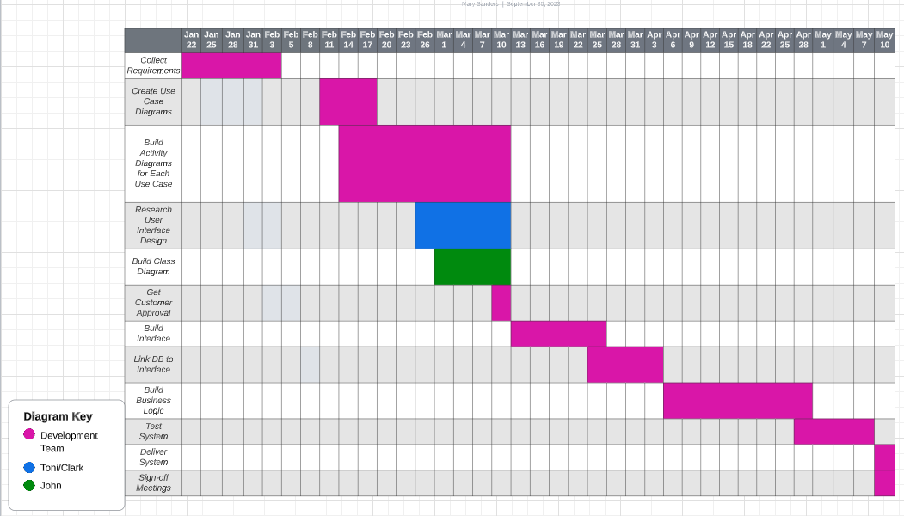

**References**

Valacich, J. S., & George, J. F. (2019). Modern Systems Analysis and Design (9th ed.). Pearson Education (US). https://mbsdirect.vitalsource.com/books/9780135172827